Student Handout
Mapping
BEACO2N aims to give insight into understanding greenhouse gas emissions through their work of providing almost real-time data on air pollutants through BEACO2N nodes located across the Bay Area. To learn more about BeaCO2N and its mission, feel free to read more at beacon.berkeley.edu/about.

Conceptual Review
We have become very familiar with datasets that deal with air pollutants. Let’s go over some conceptual questions about air pollution/geospatial data.
- Briefly describe what air pollution is and how it is caused. How do air pollutants move through the atmosphere?
______________________________________________________________________________________________________________________________________________________________________________________________________________________________________________________________________________________________________________________________________________________________
- Write each air pollutant and its respective units of measurement.
______________________________________________________________________________________________________________________________________________________________________________________________________________________________________________________________________________________________________________________________________________________________
- Why is it important to use maps? When should we use line plots, over histograms, over maps/GIFs?
______________________________________________________________________________________________________________________________________________________________________________________________________________________________________________________________________________________________________________________________________________________________
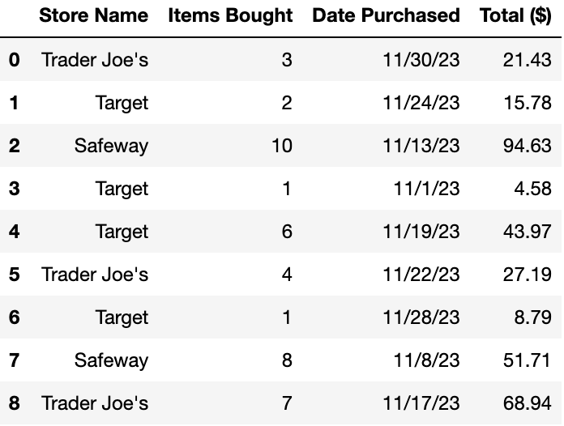
Assume we can access data from Trader Joe’s, Target, and Safeway. The table on the left displays this data. Use it to answer the questions in Sections 2 and 3.
Note: This dataset is completely made up for the purpose of these questions.
Assume this DataFrame is assigned to the store_data variable.

Learning About the Data (Data Granularity)

- What does each row in store_data represent? What information does this DataFrame tell you?
______________________________________________________________________________________________________________________________________________________________________________________________________________________________________________________________________________________________________________________________________________________________

- What is the data type (ie, string, int, float, timestamp) of each column? Indicate the unit of measurement for any column(s) that have units.
______________________________________________________________________________________________________________________________________________________________________________________________________________________________________________________________________________________________________________________________________________________________

Grouping Data

As we can see from the notebook, grouping data can tell us some interesting things! One attribute we can group by with the store_data DataFrame is Store Name.
- Let’s say we were to run the below code. Describe what it will output! Feel free to draw out the new DataFrame and/or describe it.
store_data.groupby("Store Name").sum()
______________________________________________________________________________________________________________________________________________________________________________________________________________________________________________________________________________________________________________________________________________________________
- Let’s say we were to run the below code. Describe what it will output! Feel free to draw out the new DataFrame and/or describe it.
store_data.groupby("Store Name").mean()
______________________________________________________________________________________________________________________________________________________________________________________________________________________________________________________________________________________________________________________________________________________________

Visualizing Spatial Data

Now let’s jump into understanding and visualizing maps.

Part 1: Understanding Shapefiles
In the In-Class and Student Exploration notebook, we ran cells that created the map of the Bay Area. These maps are all created by reading a shapefile.
Definition: A shapefile is a popular geospatial vector data format for analyzing geographic information. Created by Esri, shapefile consists of a collection of files with extensions like .shp (shape format), .shx (shape index format), and .dbf (attribute format).
Note: While you do not have to understand all the collection of files, you can further investigate by looking into the data files used for this Notebook if you are interested in data processing, analysis, and processing! You can see the collection files in the beacon-mapping-files-main folder by clicking on the folder icon on the left menu bar in your notebook.

Part 2: Understanding Maps

When looking at maps, we can look at their latitude and longitude as features. Latitude and Longitude are a set of coordinates used to determine the precise location of any point on the Earth's surface.
- Latitudes are horizontal lines running from East to West, indicating north-south positions.
- Longitudes are vertical lines running from North to South, indicating east-west positions.
In the following questions, we will look at different sets of latitude and longitude. Go to Google Maps and type in these geographical vector points to answer what recognized landmarks are represented by these latitudes and longitudes.
Example: Coordinates 35.36139452784725, 138.72706293491046 ⇒ Fuji, Japan
- What famous landmark is located at these coordinates: 51.50082268197, -0.12462943021060194?
______________________________________________________________________
- What famous landmark is located at these coordinates: 48.858490069828335, 2.294534941194745?
______________________________________________________________________
- What famous landmark is located at these coordinates: 37.82703327196858, -122.42308536308465?
______________________________________________________________________
- What famous landmark is located at these coordinates: 41.89039386784884, 12.492263083143206?
______________________________________________________________________
- What famous landmark is located at these coordinates: -33.856597271920684, 151.21526450975105?
______________________________________________________________________
- What famous landmark is located at these coordinates: 43.089710944542134, -79.0851896189112?
______________________________________________________________________
The first letter of these recognized landmarks should spell BEACON!
Part 3: Analyzing Data within a Map
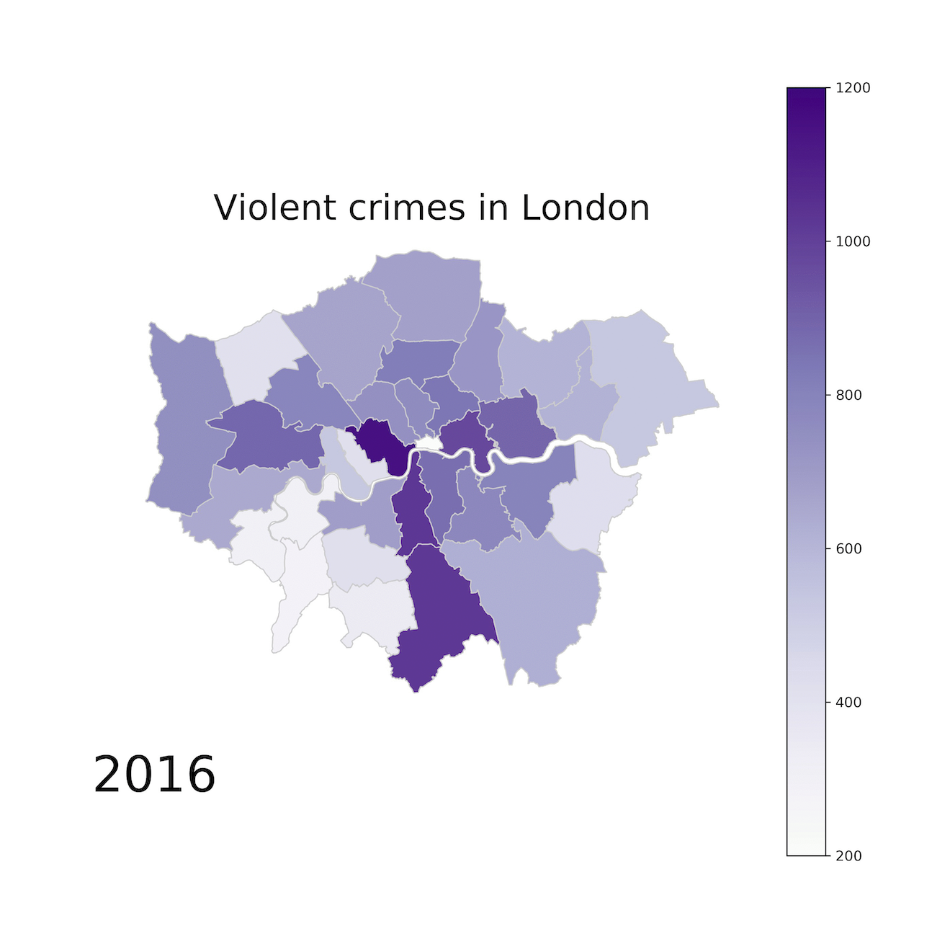
Let’s say we are working with London crime datasets.

(Map created by Ben Dexter Cooley)
Each point or shaded area on the map represents a specific geographic location where data was collected or an event occurred, in this case, instances of violent crime. While we had points/dots representing data in the Mapping Notebook, this graphic uses the shade for each borough (district) in London to represent the data. This was done by aggregating the collection of data points in each borough. Darker shades typically indicate higher values in the color scale, whereas lighter shades indicate lower values – but always verify the colormap! With these features in mind, let’s answer some conceptual questions below.
- How do the concentrations of data points relate to the geographic features of the area (ie, urban vs. rural, proximity to landmarks)? Use this map of London (by borough) [https://londonmap360.com/london-boroughs-map] and its descriptions (or Google!) to find these details and compare.
______________________________________________________________________
______________________________________________________________________
______________________________________________________________________
______________________________________________________________________
- What patterns can you discern from the distribution of violent crimes in London as shown on the map?
______________________________________________________________________
______________________________________________________________________
______________________________________________________________________
______________________________________________________________________
- How might policymakers or law enforcement use this data to allocate resources or plan interventions to prevent violent crimes?
______________________________________________________________________
______________________________________________________________________
______________________________________________________________________
______________________________________________________________________

